

ABC Awards Level 2
Motor Vehicle Studies

Underpinning Knowledge Evidence Record

F/601/3747 Knowledge of Removing and Fitting Basic Light Vehicle Mechanical, Electrical and Trim (MET) Components and Non Permanently Fixed Vehicle Body Panels

Learners Name
ABC Awards Registration Number
Centre Name
Assessor 1 Name
Assessor 2 Name

DECLARATION OF AUTHENTICITY

This declaration must be completed and signed by the learner and countersigned by the tutor / assessor and covers all evidence submitted for moderation.

Learner Name
Unique Learner Number (ULN) |  | ABC  Learner Reg. ID
Qualification Title
Centre Name

Learner statement of authenticity

Before signing please read the guidance below.

I confirm, that the attached assignment / portfolio is all my own work and does not include any work completed by anyone other than myself. I have completed the assignment / portfolio in accordance with ABC Awards’ instructions and within the time limits set by my centre.

Signature |  | Date

Centre confirmation of authenticity

On behalf of …………………………………….(insert centre name), I confirm that the above mentioned learner, to the best of my knowledge, is the sole author of the completed assignment / portfolio attached, and the assessments have been completed under the required conditions.

Signed |  | Date
Name
Title

Guidance for Learners

You have been asked to sign this Declaration of Authenticity and place it at the front of your portfolio or course work assessment. It confirms that the work you have submitted for assessment is your own and that you have not copied it from someone else or allowed another learner to copy it from you.

When preparing any course work it is good practice to undertake research using information from published sources. If you quote directly from these sources then this must be indicated in your work by using quotation marks and referencing the document from which the quotation was taken. You must then comment in your own words on any ideas expressed.

Assessors, internal verifiers and ABC Awards’ external moderators and verifiers are subject specialists who can spot the use of published materials that may be passed as your own words or ideas.
If you do copy words from a published source and do not indicate their reference you will be committing plagiarism. This is considered a form of cheating and may result in your assessment being declared void.
Contents

Task No | Title | Assessment Criteria
1 | Procedures for removing and re-fitting MET components | 1.1, 1.2, 1.3, 1.4, 1.10, 2.2, 2.3, 2.4, 2.9
2 | Fastenings and fixings | 1.5, 1.6, 2.5
3 | Quality checks | 1.7, 1.8, 1.9, 2.6, 2.7, 2.8

Task 1 – Procedures for removing and re-fitting MET components | Assessment Criteria 1.1, 1.2, 1.3, 1.4, 1.10, 2.2, 2.3, 2.4, 2.9

Use the diagram below to identify any pre-existing damage and state how you would report this
Vehicle Details |  |  | 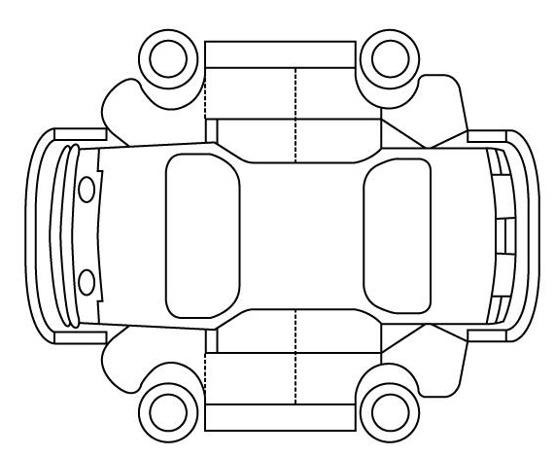  Vehicle Body Report
Make__________________________

Model__________________________

Registration/VIN No._______________

Colour__________________________

Components and non permanently fixed panels to be removed and re-fitted | Remove  | Sources of Information Used
 | Remove  | Manual   |  | Autodata   | Thatcham eScribe   | Internet   | Other  (State)
Bumpers
Headlamp units
Road wheels
Batteries
Bonnet and boot trim
Interior trim components
Exterior trim components
Explain the procedures involved in the removal and refitting of the selected components
Explain the procedures involved in working with gas discharge headlamp systems
(include any special precautions or procedures)

Identify the procedures and precautions you would use when working with supplementary safety systems (e.g. SRS, Airbag)
Light Vehicle Component/Panel Storage
Components to be removed and re-fitted | Explain the correct storage method
Bumpers
Headlamp units
Road wheels
Batteries
Bonnet and boot trim
Interior trim components
Exterior trim components

Task 2 – Fastenings and fixings | Assessment Criteria 1.5, 1.6, 2.5

Identify different types of fastenings and fixings used when removing and re-fitting the chosen MET component
Body Mechanical/Electrical |  | Trim
Type | Where Used | Type | Where Used
From the list of fixings above explain the reasons for the use of the different types of fasteners and fixings

Task 3 – Quality checks | Assessment Criteria 1.7, 1.8, 1.9, 2.6, 2.7, 2.8

Alignment and Quality Checks
Explain the following:
How to correctly align chosen components
Reasons for correct alignment
List the quality checks associated with:
1 Electrical component
1 Mechanical component
1 Trim component
Identify correct conformity of vehicle systems against vehicle specification (e.g. legal requirements)

Unless otherwise stated e.g. for some entry level qualifications, learners can work together but should identify sections which are their own work.

